|  |  |  |  |  |  |  |  |  |  |
| --- | --- | --- | --- | --- | --- | --- | --- | --- | --- |
| AIUB  **American International University- Bangladesh (AIUB)**  **Faculty of Engineering (EEE)** | | | | | | | | | |
| **Course Name:** | | | Microprocessor & Embedded System | | **Course Cd:** | EEE 4211 | | | |
| **Semester:** | | | Summer 18-19 | | **Sec :** | A | | | |
| **Faculty:** | | | Sajid Hossain | |  |  | | | |
|  | | | | | | | | | |
| **Project Title:** | | | Design Of A Bluetooth Based Home Automation Service Using Arduino Android Application. | | | | | | |
|  | | | | | | | | | |
| **Group Members** | | **ID** | | **Name** | | **Marks (55)** | | | |
| Prsnt/Demo.  (15) | Viva  (20) | Rept.  (20) | Total  (55) |
|  | 1. | 16-32113-2 | | Khan, Muhammad Jahid Hossain | |  |  |  |  |
|  | 2. | 16-32430-2 | | Bhuiyan,Shariful Islam | |  |  |  |  |
|  | 3. | 16-32243-2 | | Ajijul Hakim | |  |  |  |  |
|  | 4. | 16-31660-1 | | Razzaque Syeda Tasnuva, | |  |  |  |  |
|  | 5. | 16-32374-2 | | Fahim,Sadman Chowhury. | |  |  |  |  |
|  | | | | | | | | | |
| **Submission Date :** | | | **01/08/2019** | | **Due Date :** | **01/08/2019** | | | |

[1]

Design Of A Bluetooth Based Home Automation Service Using Arduino Android Application

Khan, Muhammad Jahid Hossain ., Bhuiyan,Shariful Islam, and Ajijul Hakim, Razzaque Syeda Tasnuva, and Fahim,Sadman Chowhury.

*Abstract*—Technology which is emerging throughout the life of the people of the world. To be able to design a system using current technology that would be beneficial for society will be a huge contribution to the community. This Project Aims at Providing a Bluetooth based home automation system using Arduino Uno And Android Application. This is a remote controlled based project which gives a simpler version of home automation system using Android technology. Remote control can be done using any smart phone tab with android technology

*Index Term*—Arduino Uno, Android Application, Bluetooth, Step Down Transformer, Sensors .

# INTRODUCTION

W

Ireless technologies are getting bigger and bigger and getting more and more popular among the people of the world and they are really liking this new form of technology that allow them to be free from “cable chaos”. In the present era, security systems play an vital role in protecting the lives and investment. A fully smart home system is one that is equipped with lighting, switching fan, showing temperature, and electronic devices that can be controlled remotely by smartphone or via the internet. With the embedded system in Bluetooth nowadays device and application and also human can communicate with each other. Recently Home Automation is one of the biggest application of Bluetooth technology .Without the license with the frequency of 2.4Ghz, it can connect devices from 10m to the distance of 100m with the speed of 3mbps.depanding on class of Bluetooth. We are offering a home automation system with the help of Bluetooth.[1].

For Showing the temperature and humidity DH11 sensor is used for this purpose.DH11 temperature and humidity sensor forms a temperature and humidity sensor complex with a calibrated digital signal output. By using this sensor it ensures high reliability and excellent long-term stability. This sensor includes a resistive-type humidity measurement component and an NTC temperature measurement component, and connects to a high performance 8-bit microcontroller, offering

Excellent quality, fast response, ant-interference ability and cost-effectiveness.[2]

# Over view of the smart home system

This smart system consists of an Arduino microcontroller Atmega 328, Bluetooth module, Relay drivers, step down transformer and Android application .The Bluetooth Module is used to connect the system with the Android application so that it can be controlled remotely within the range of Bluetooth .The basic block Diagram Of the smart home system is shown in figure 1.A micro-controller is used to obtain values of physical conditions through sensors connected to it . These  
integrated sensors such as the temperature, humidity. Relays act as electro-magnetic switch used for switching ON and OFF the appliances. Loads are connected individually with the relays.[2].Bluetooth Electronics software is used to control and also see the temperature and humidity.

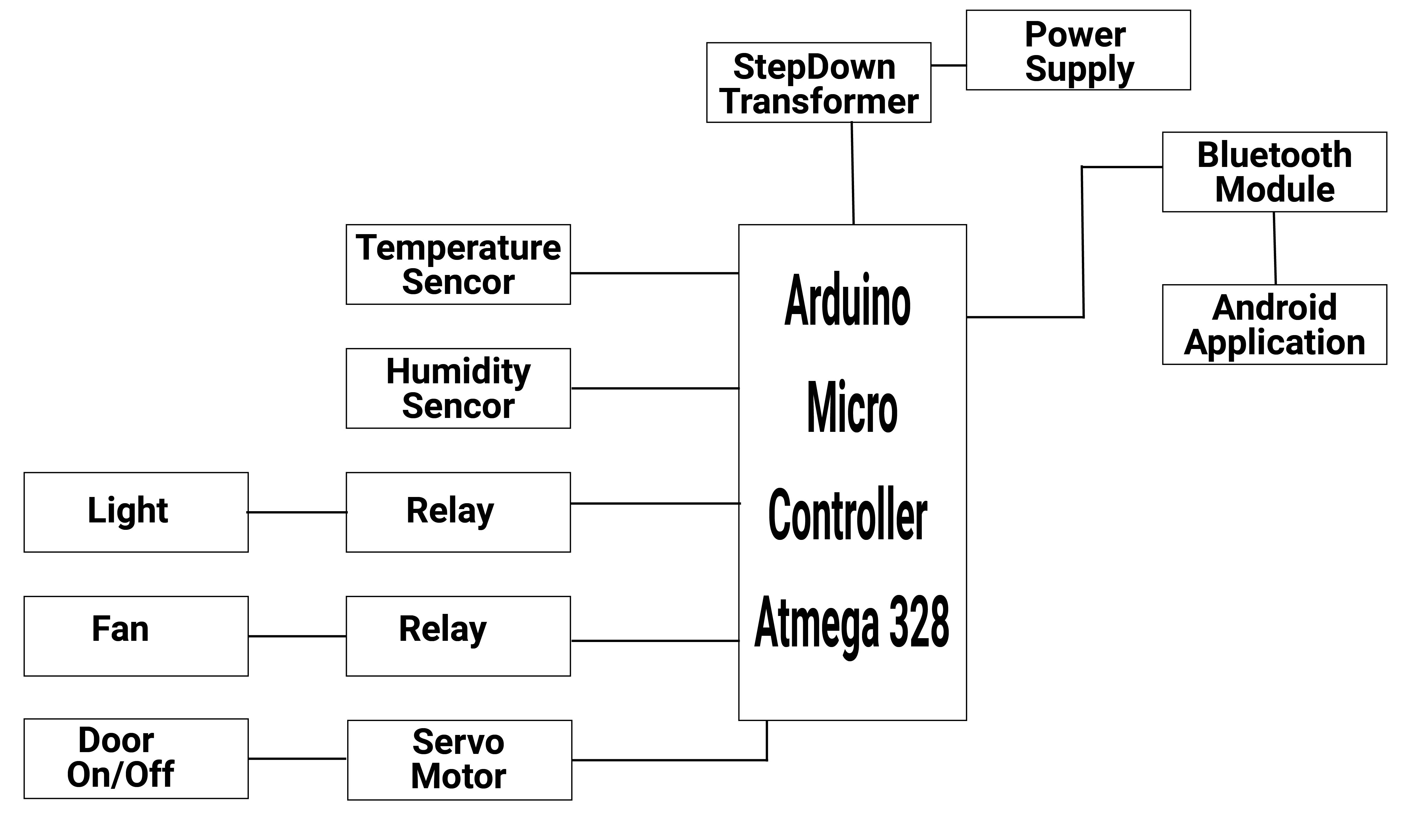

**Figure-1**: Block Diagram Of the Home Automation System

# Hardware Description

## Arduino Microcontroller Atmega 328p

The high-performance Microchip picoPower 8-bit AVR RISC-based microcontroller combines 32KB ISP flash memory with read-while-write capabilities, 1024B EEPROM, 2KB SRAM, 23 general purpose I/O lines, 32 general purpose working registers, three flexible timer/counters with compare modes, internal and external interrupts, serial programmable USART, a byte-oriented 2-wire serial interface, SPI serial port, a 6-channel 10-bit A/D converter (8-channels in TQFP and QFN/MLF packages), programmable watchdog timer with internal oscillator, and five software selectable power saving

modes. The device operates between 1.8-5.5 volts.

By executing powerful instructions in a single clock cycle, the device achieves throughputs approaching 1 MIPS per MHz, balancing power consumption and processing speed.[3]

## DHT11 TEMPERATURE AND HUMIDITY SENSOR

 They consist of a humidity sensing component, a NTC temperature sensor (or thermistor) and an IC on the back side of the sensor. For measuring humidity they use the humidity sensing component which has two electrodes with moisture holding substrate between them. So as the humidity changes, the conductivity of the substrate changes or the resistance between these electrodes changes. This change in resistance is measured and processed by the IC which makes it ready to be read by a microcontroller On the other hand, for measuring temperature these sensors use a NTC temperature sensor or a thermistor. A thermistor is actually a variable resistor that changes its resistance with change of the temperature. These sensors are made by sintering of semiconductive materials such as ceramics or polymers in order to provide larger changes in the resistance with just small changes in temperature. The term “NTC” means “Negative Temperature Coefficient”, which means that the resistance decreases with increase of the temperature.[4]

## Bluetooth Module

HC-05 Bluetooth Module which is very much easy to use Bluetooth SPP (Serial Port Protocol) module That is designed for transparent wireless serial communication setup. Its communication is via serial communication that makes an easy way to interface with microcontroller or PC. HC-05 Bluetooth module provides switching mode between master and slave mode which means it able to use neither receiving nor transmitting data.[5]

## Relay

Relay is an electromagnetic equipment that is used to isolate two circuits electrically and connect magnetically. One circuit allow switching where another one while they are completely separate with each other. They are often used to interface an electronic circuit (working at low voltage) to an electrical circuit which works at very high voltage.[2]

## Android Software(Bluetooth Electronics)

With the growth of Arduino, Raspberry PI and other rapid development systems, what can be achieved by makers, hobbyists and professionals in a short time frame is impressive that is made by Keuwlsoft electronics.

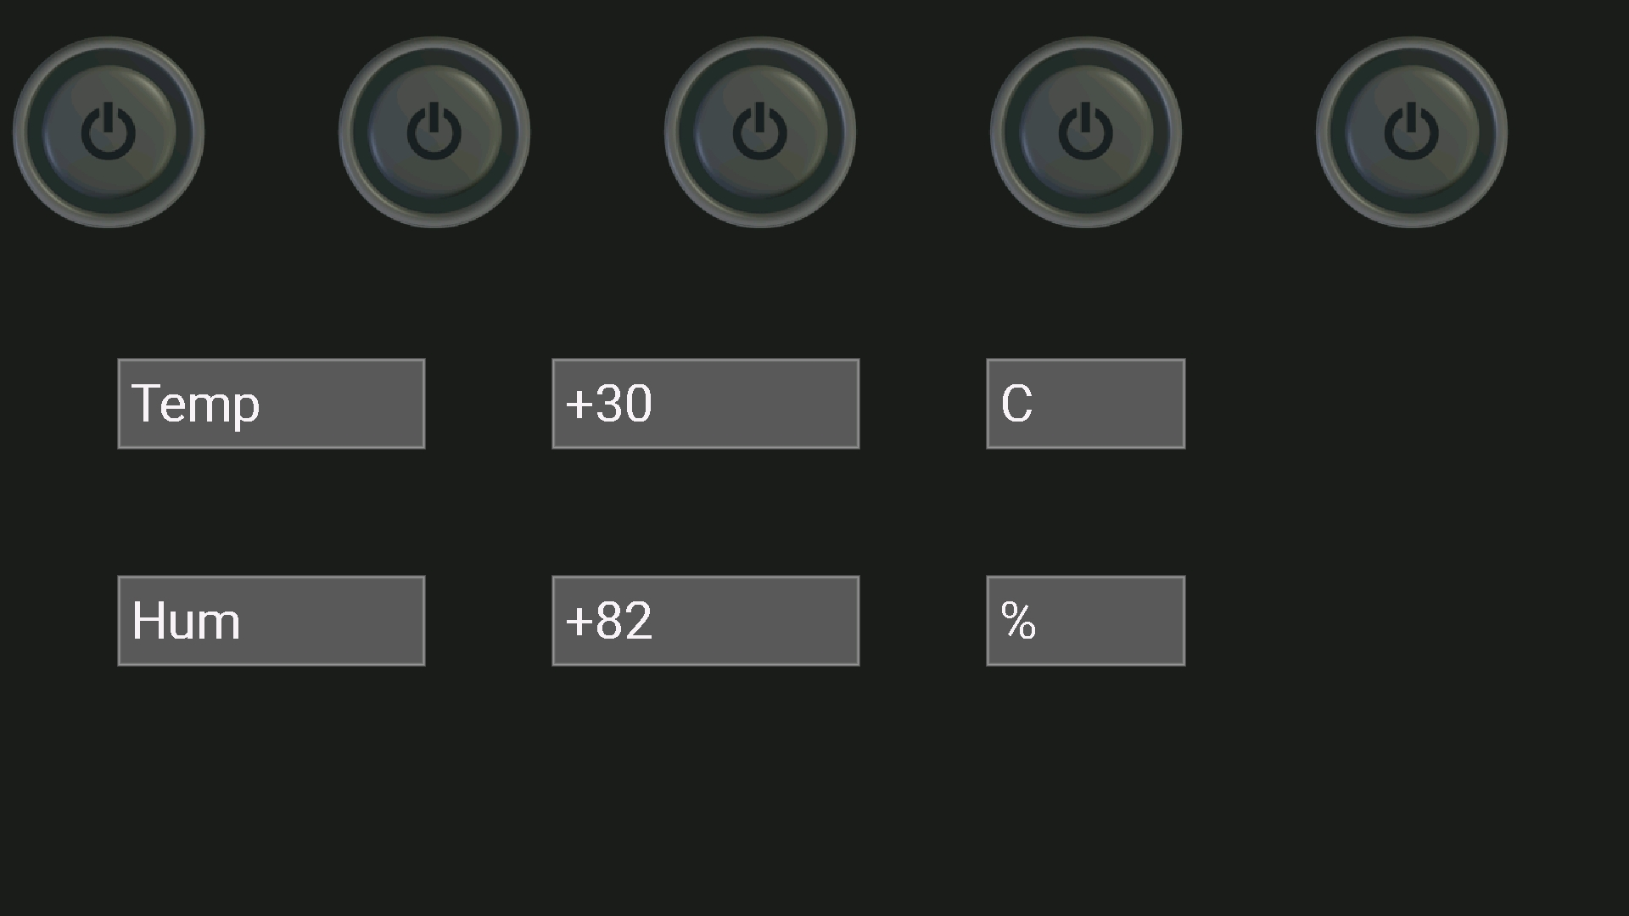

Figure-2: Interface Of Bluetooth Electronics .

# DESIGN AND IMPLEMENTATION

A low price and cost-effective smart home system is presented in our design. This system has two main modules: the hardware interface module and the software communication module.

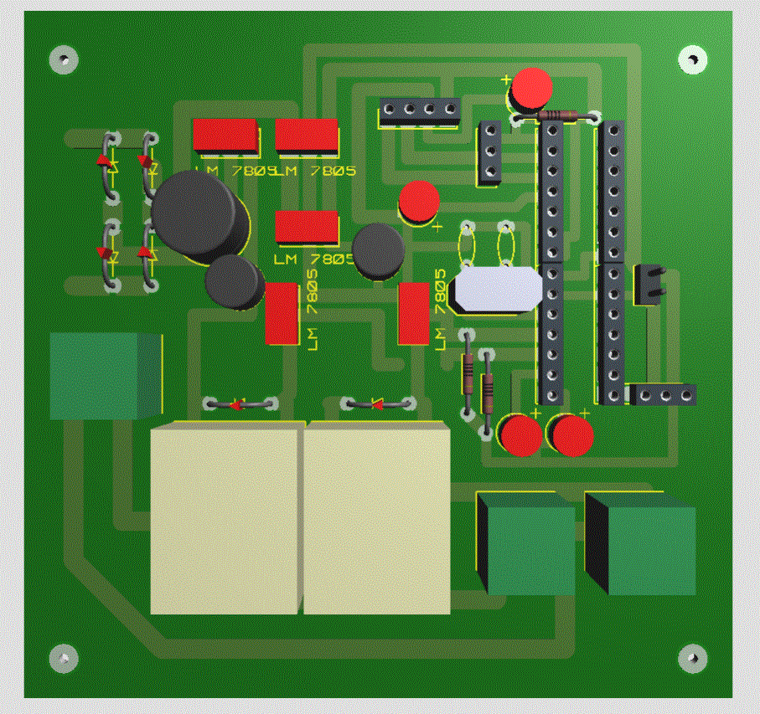

**Figure**-3: PCB Design Of Smart Home Service

This Design is the simplest version of home automation system.

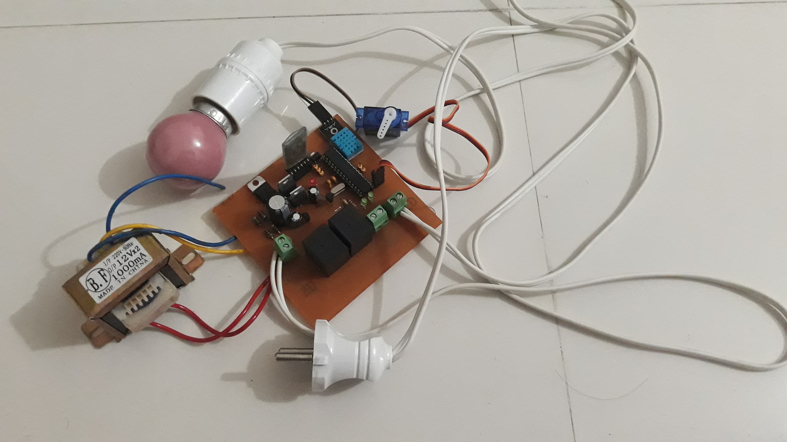

**Figure-4**:Hardware Implementation of Home Automation .

# Testing and Result

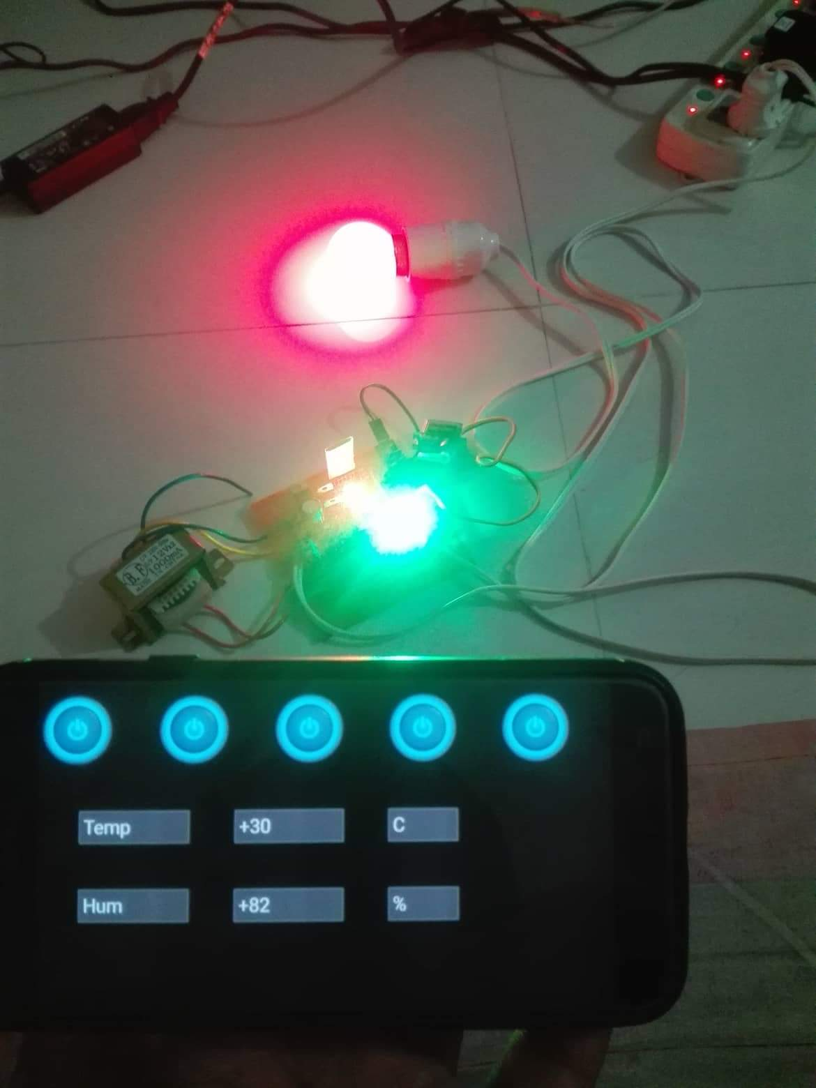

**Figure-5**: Testing Of The System

This Represent The Test and working of the system that is designed with the help of above mentioned equipment.

# Cost Analysis

|  |  |  |
| --- | --- | --- |
| Serial No | Equipment | Cost |
| 1 | Atmega 328p | 120 |
| 2 | Bluetooth Module | 220 |
| 3 | Relay | 15 |
| 4 | PCB layout | 50 |
| 5 | Regis,cap,wire | 30 |
| 6 | DHT11 | 120 |
| 7 | Step down transformer | 250 |
| 8 | Light Fan socket | 120 |
| 9 | Servo Motor | 300 |

.

# Conclusion

## In this project, a reliable, easy, fast and low cost smart home system using Arduino microcontroller Atmega 328p and Android app. has been proposed, implemented and tested. This proposed system uses Bluetooth module for fast and reliable communications in between the remote user and home devices. Future aspect of this project is to incorporate various applications of servomotor, voice recognition module especially for the physically disabled individuals and auto sensing system to check the status of various devices, when individual is outside of his/her home.

References

1. The official Bluetooth website from Bluetooth SIG:  
   http://www.bluetooth.com.
2. “<https://www.mouser.com/ds/2/758/DHT11-Technical-Data-Sheet-Translated-Version-1143054.pdf>”,Last accessed on 31 july,2019,on 1.23pm.
3. “<https://www.microchip.com/wwwproducts/en/ATmega328p>” , Last Access On 31 July,2019,On 7.47pm.
4. “<https://howtomechatronics.com/tutorials/arduino/dht11-dht22-sensors-temperature-and-humidity-tutorial-using-arduino/>” Last Access On July 31, 2019,8.13 PM.
5. <https://www.gme.cz/data/attachments/dsh.772-148.1.pdf>

Last Access On July 31, 2019.8.46 PM.

1.